CHE517 ADVANCED PROCESS CONTROL
FINAL EXAM
Professor Shi-Shang Jang Jan. 13, 2005

Problem #1 (20%)
Interpretation
- Smith predictor
- Cascade control
- Zero-order hold
- Interaction problem of multi-variable system

Problem #2 (20%)

Consider the following Internal Model Control Structure (or Model Predictive Control Structure:
G_{I}
G_{m}
G_{P}
y_{s}
e
d
y
y_{m}
u
+
+
+
-
-
+

Show that:

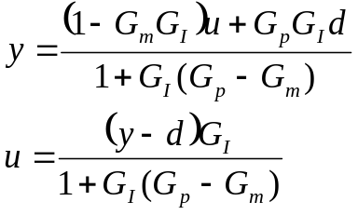

Based on the above derivation, also show that:
- Dual stability: y and u are both stable provided that G_{p}=G_{m}, G_{p} and G_{I} are stable.
- Perfect Control: y=y_{s} provided that G_{p}=G_{m}, G_{p}=G_{I}⁻¹ and G_{I} realizable.
- Zero offset: y(0)=y_{s}(0) provided that G_{m}(0)=G_{I}⁻¹(0).

Problem #3 (20%)

Derive a pulse transfer function (z-domain) for the following plants with a zero order hold and a sampling time of 1:
- 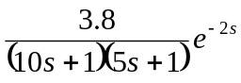 (7 points)
- 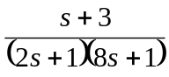 (7 points)
- 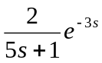 (6 points)

Problem #4 (20%)

For a liquid storage system shown in the following figure, ir is desired to control liquid levels h₁ and h₂ by adjusting volumetric flow rates q₁ and q₂. Flow rate q₆ is the major disturbance variable. The flow-head relations are given by:

where Cv1, Cv2 and K are constants.

- Derive an expression for the relative gain array for this system.
- Use the RGA to determine the recommended paring of controlled and manipulated variable for the following conditions:

Parameter Values:
K=3 gal/min ft
C_{v1}=3 gal/min ft^{0.5}
C_{v2}=3.46 gal/min ft^{0.5}
D₁=D₂=3.5 ft (tank diameters)

Nominal Steady-State Values
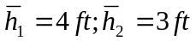
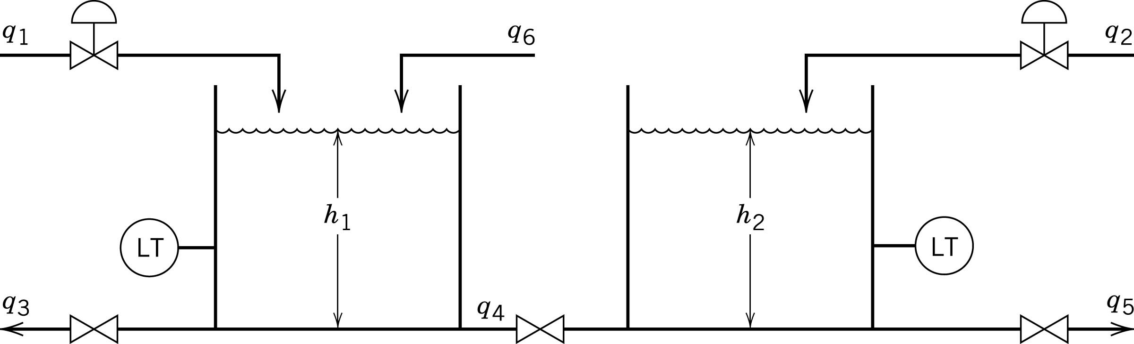

Problem #5 (20%)

A mixing vessel is used to maintain the desired pH level in a stream flowing to a waste treatment plant. The pressure to the valve on an acid stream is used as the manipulated variable. Most of the variability in pH is due to waste stream 1, which is a caustic stream. It is desirable to implement a feed-forward controller to reject the pH disturbances due to this stream. The following data are relevant to this problem. Without control, a change in the inlet pH of 0.5 leads to a change of 0.25 pH in the outlet stream. The time delay is 10 minutes and the time constant is 30 minutes. A change in the acid stream valve-top pressure of 1 psig leads to a change in pH in the outlet stream of 0.4 pH. The time constant is 25 minutes and the time delay is 7.5 minutes.

Design a feed-forward controller for this process. Show units.
